Lauren Malicsi
Tasha Candela
Career Field Experience
November 30, 2016
Beaumont Family Medicine
“There is no elevator to success. You can only take the stairs”. This quote relates to my placement because being a part of Beaumont was the start of my future success. In my Career Field Experience class, I was required to job shadow at Beaumont Family Medicine. In my opinion, Career Field Experience is a unique class because it gave me experience that a normal classroom would never give me. For thirteen weeks, I was able to experience patient care in a healthcare facility. I had the chance to shadow different employees such as Medical Assistants, font desk workers, and infusion nurses. While reflecting on my overall learning experience in this class, I will outline three employability skills including professionalism, having a positive attitude and teamwork and how I have grown as a professional.
The first employability skill I chose is professionalism. Being in a medical office, it was crucial for me to act professional. Although I believe I am a rather professional person, I did not realize how serious it can be. I dealt with many different patients, and with that came many different attitudes and personalities. Although the majority of them were kind, there were some that tested my professionalism. I did my best to always keep a smile on my face and ignore any negative behavior, and I think that helped with my professional skills. It was a very different change of pace going from being around teenagers all day, to being around adults.
The next skill I chose is having a positive attitude. I think that having a positive attitude is very important in general, and especially in a healthcare facility. During my time at Beaumont, I was surrounded by so many positive attitudes. Everyone there was super kind to me, and it helped make my whole experience so great. When I was learning how to do tasks such as taking temperature, weight, height, and blood pressure, I always kept a positive attitude. Although those tasks may seem simple, it is way different when you actually do them on a patient. In the beginning I was discouraged at times, but with keeping a positive attitude, I was confidently completing these tasks after days of learning how to do them.
The last skill I chose is teamwork. One of the main things I learned during my experience is that teamwork is very important. At Beaumont, they have two different teams with medical assistants. All of the medical assistants work with their team and make sure everything stays on task. Although technically each assistant gets their own charts, others would help by grabbing different charts so everyone stays on task. It helped me realize that no matter whether I like the people I work with or not, teamwork needs to happen. It will make the overall work experience easier.
I am very happy with my final evaluation sheet. It has significantly improved since my last evaluation. Nancy wrote that my smile is contagious, which makes me happy. I always try to make sure to be on my best behavior there, so I am happy they noticed. Also, I received a “5” on oral communication which I am glad about because at first I was slightly timid when it came to communicating with staff and patients. I am definitely more comfortable now with everyone. I received a “3” on work initiative, which is understandable. At times I am not confident enough with a task I am performing, and I wait to do something until I am asked. I am working on becoming more confident with that, and I know I will get there with more practice.
This experience has changed me as a person in so many ways. Coming out of this, I believe I am a more professional person, with improved skills such as patience and responsibility. Also, this experience has helped me know exactly what I want to do in the future. I will never forget listening to all of the crazy stories from patients in the Cardiac Rehab Unit, there was never a dull moment in there. I would definitely recommend this experience to a friend. It was truly life changing and I think anyone should take advantage of this opportunity. Fortunately, I will be continuing my Career Field Experience next trimester in the Cardiac Rehab Unit at Beaumont. I am very excited and grateful. As for the future, I am hoping to attend Michigan State University for Nursing.

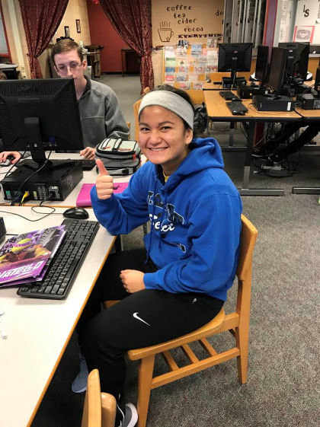
Positive attitude

Teamwork Professionalism
